Documentation For 3D Blocks Game

Running the application
“\executable\AppMain.jar” is the executable file. The other files in this directory are required for AppMain.jar to be launched properly.

Source code files in \source-with scene graph window\” need to be run with an external .jar file provided along in the directory. The source code files in “\source-original\” can be run with normal java3d environment.

There is only one difference between the two versions of source code. One of them have a window displaying scene graph design when the application is launched, the other doesn’t. There are only a few lines of differences in coding. The two versions are provided for making it more convenient to see the scene graph design without effecting the game itself when running.

Requirement and rules
This java application is a single-player 3D game. Each level of the game is composed of a series of cubics which form a board. There is a restriction of time and max steps for each level of the game. Each cubic is assigned a color initially. The player can step on each block with arrows keys. And the blocks already stepped on would be assigned a different color. When all the blocks are in the same color,the player wins this level. If the player can't finish it with the restricted time and number of steps, the player would lose.

Scene Graph Design
When \executable\AppMain.jar is launched, two windows would appear at the same time. One is for the game itself, the other is for displaying the scene graph structure in this program. A screen shot of the scene graph window is shown below.

The generating of the scene graph window uses an external jar (j3dtree.jar) obtained from www.manning.com/selman/. Please launch the application and see the details of the scene graph design structure.

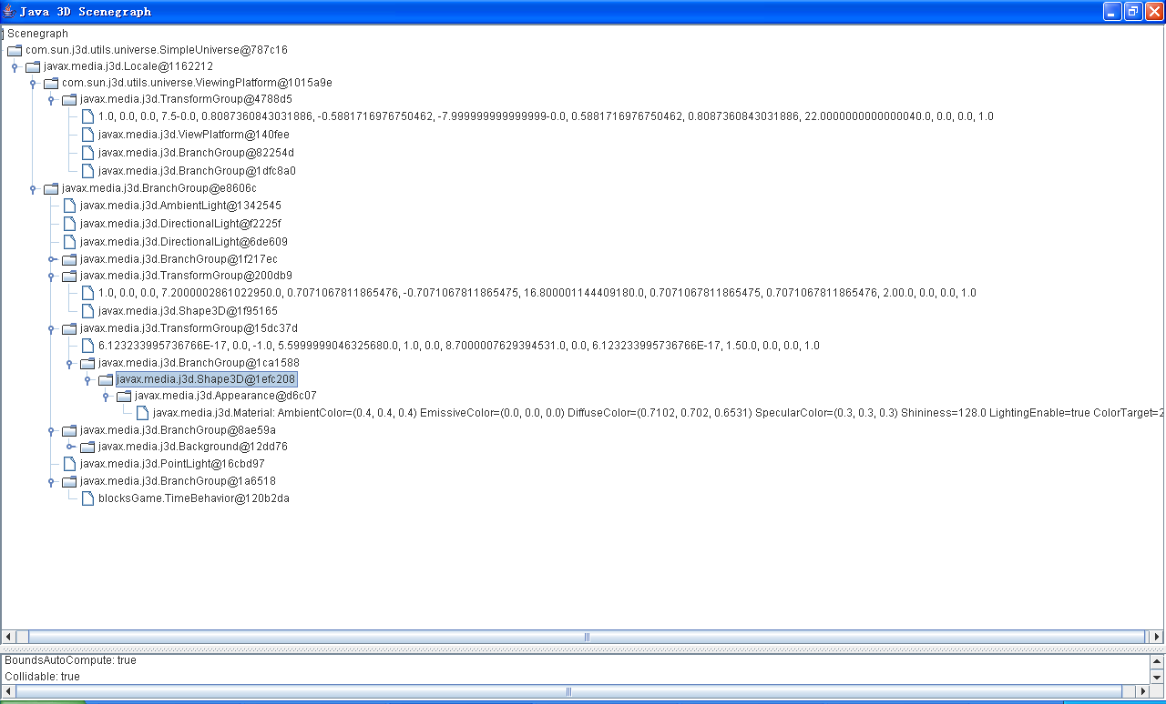

Class design
See javadoc files

Implementation
See code and javadoc files

Testing

The screen shot are as follows

The blocks already stepped on are assigned a different color as a mark.
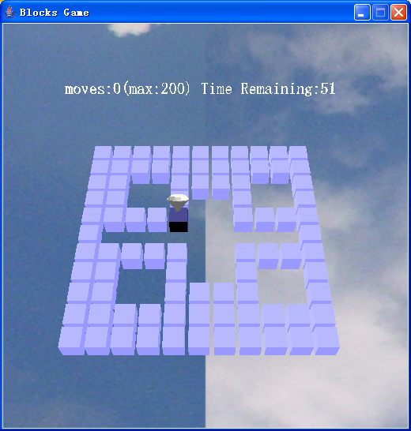

When the player can't finish in the restricted time, s/he would lose the
game.

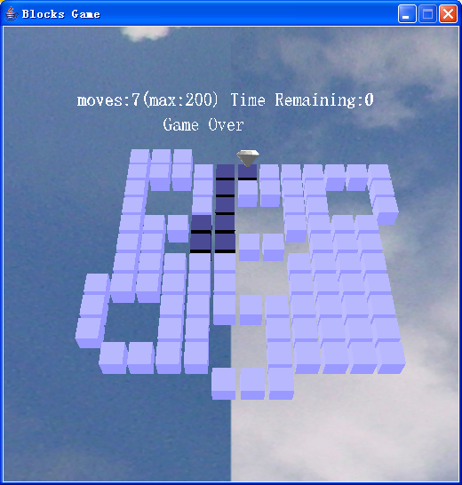

The player would win the game when all the levels(3 levels in total) are finished.

